



https://secure.getmeregistered.com/CornCarnival

Saturday, June 14th, 2025
Race Time: 8:00 a.m.
South Side of City Park
509 Washington St
Gladbrook, IA

Corn Carnival 5K/Walk registration form or
Register on-line: https://secure.getmeregistered.com/CornCarnival
Name: _________________________________________ Phone:_______________________________
Address: _______________________________________ City, State Zip__________________________
Email: _________________________________________
Check your Payment: In order to compete, you must be in good health and physically prepared to take on the challenges of the event you register for. Registration is available in advance or on race day. Skateboards, skates, and bikes, are prohibited on the course. Online and mail in registration for the 5K race closes on June 6, 2025. Register by June 6, 2025 to be guaranteed a t-shirt for 5K run and walk participants.
◻ 5K $25 ◻ 5K after June 6 $30 ◻ 2 Mile Walk $25 ◻ 2 Mile Walk after June 6 $30

◻ No T-shirt; $5 discount ◻ Kids Dash FREE (no t-shirt)
◻ I am not able to participate in this race but please accept my donation $________ enclosed.
5K Age category: ◻ 9 and under ◻ 10-14 ◻ 15-19 ◻ 20-29 ◻ 30-39 ◻ 40-49 ◻ 50-59 ◻ 60-69
◻ 70+
Gender: ◻ Male ◻ Female
T-Shirt Size (Limited Quantities): ◻ S ◻ M ◻ L ◻ XL ◻ 2XL ◻ 3XL (2 & 3 XL add $4)

WAIVER AND RELEASE OF ALL CLAIMS AND ASSUMPTION OF RISK:
Please read this form carefully and be aware that in signing up and participating in this event, you will be expressly assuming the risk and legal liability and waiving and releasing all claims for injuries, damages, or loss which you or your minor child/ward might sustain as a result of participating in any and all activities connected with and associated with this event. I recognize and acknowledge that there are certain risks of physical injury to participants in this event, and I voluntarily agree to assume the full risk of any injuries, damages, or loss, regardless of severity that my minor child/ward or I may sustain as a result of participating in any and all activities connected with or associated with this activity. I further agree to waive and relinquish all claims I or my minor child/ward may have (or accrue to me or my child/ward) as a result of participating in this activity against the City of Gladbrook, any political subdivision, and the Corn Carnival Corporation, including its respective officials, agents, volunteers, and employees (hereinafter collectively referred as “Parties”). I do hereby fully release and forever discharge the Parties from any and all claims for injuries, damages or loss that my minor child/ward or I may have or which may accrue to me or my minor child/ward and arising out of, connected with, or in any way associated with this activity. I further agree that this agreement shall be governed by the State of Iowa. I have read and fully understand the above important information, warning of risk, assumption of risk and waiver and release of all claims. If registering on-line signature shall substitute for and have the same legal effect as an original form signature.

_________________________________ ________ ______________________________ _______
Signature of Applicant Date Signature of Parent (if under 18) Date

Please make checks payable to: CCC (Corn Carnival Corp.)
Send payment & registration to: Crystal Petersen 1334 C Avenue Gladbrook, IA 50635

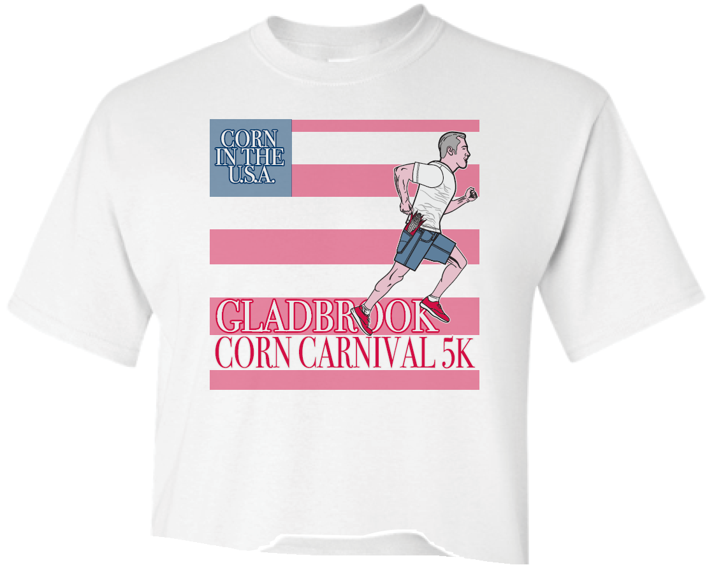
103rd Corn Carnival
Annual
5K Fun Run and Walk

Free Kid’s Dash at 8:45 am

Events
Corn Carnival 5K Fun Run/Walk
or
2 Mile Walk Contest – The contest is to estimate your 2 mile walk time closest to your actual finishing time.
Strollers and pets on a leash are welcome.
Skateboards, skates, roller blades and bikes are prohibited.

Times
Race Day Registration: 7-7:30 a.m.
Packet Pick-up: 7:00 - 7:30 a.m.
5K/2-Mile Walk Start: 8:00 a.m.
Kid’s Dash Start: 8:45 a.m.
Awards Ceremony: 9:15 a.m.

Awards
Awards to top two finishers in each age category (men and women). Top two 2 Mile walk contest participants. All registered participants are eligible for door prizes.

Registration
Register by mail using this form. Register online at: https://secure.getmeregistered.com/CornCarnival

Early registration ends June 6. Race day registration will be available – additional $5 fee applied.

Gladbrook Corn Carnival 5K Fun Run/Walk Information
6 Reasons to Run a 5K
1. Ease. Most of us are busy, and time is precious. You can work up to a 5K quickly and train for it adequately by training as little as three days a week.
2. Convenience. You arrive at the race, warm up for 10 to 20 minutes, race for 40 minutes maximum, cool down, replenish, and head home in your new race T-shirt.
3. Exhilaration. In a 5K, you feel like you're really racing. And that's a good feeling. Unlike a longer race, with a 5K you can motor as much as one minute per mile faster than your usual training pace.
4. Improvement. Racing an occasional 5K is an excellent fitness booster.
5. Change. Looking for variation? A fun 5K, every once in a while, is a great way to mix things up.
6. Motivation. Races are motivators. 5Ks get you out of bed when you’re tempted to simply lounge on a Saturday morning.

Packet Pick-up
Pre-Race Packet Pickup will be available on race day from 7:00 to 7:30 a.m.

Course Information

This is a 5K with variety. Runners will make their way across town on the paved streets of residential Gladbrook, then onto tree-canopied, limestone Wolf Creek Trail and loop back through or around the Tama County Fair Grounds on gravel. The race will go on rain or shine.
Restrooms available at the corner of Washington and 4th Street (northeast corner of the city park).
Enjoy other Saturday Corn Carnival Activities: www.gladbrookcorncarnival.org/event-schedule
- Pancake Breakfast
- Kid’s Activities
- Amusement Rides
- Merchant Exhibits
- Free Entertainment

